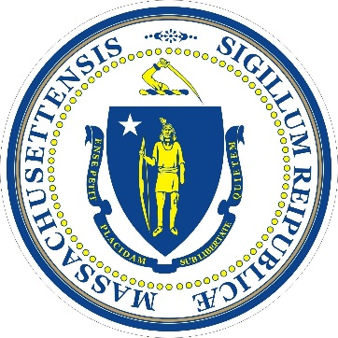
Commonwealth of Massachusetts
Executive Office of
Housing & Economic Development
Massachusetts Marketing Partnership
Massachusetts Office of Travel & Tourism
136 Blackstone Street, 5th Floor
Boston, MA 02109

FY21 REGIONAL TOURISM COUNCIL
GRANT PROGRAM
This grant is provided by the Executive Office of Housing and Economic Development (EOHED) and is administered by the Massachusetts Marketing Partnership (MMP)/Massachusetts Office of Travel & Tourism (MOTT).
*Due to the COVID-19 worldwide crisis, the FY21 Regional Tourism Council (RTC) Grant awards will be determined using the same formula as FY20 subject to appropriation.

Date:
Organization Name:
FEI#:
Primary Contact:
Email:
Phone Number:
Address:
City:
Zip:

APPLICATION OVERVIEW
The Massachusetts Office of Travel and Tourism understands that the COVID-19 worldwide pandemic is causing severe disruptions to many Massachusetts businesses, especially those that rely on tourist visitation. We also realize that RTC’s may need additional flexibility in how they spend grant funding in order to most effectively support the tourism industry under these unprecedented circumstances.

In order to make the FY21 grant application process as seamless as possible given the challenges ahead, the amount of the FY21 grant will be based on the same percentage as last year’s FY20 grant dependent on the funds available. We ask that you include projected matching funds with private sector investment and a recovery plan based on the information available to date. Once the FY21 budget has been approved, we will work diligently to get funding to the RTC’s as soon as possible in August 2020. We realize that you will need to adjust your plans based on how the crisis unfolds and want to provide the flexibility for you to meet this challenge.

To that end, please note that MOTT will waive FY20 and FY21 contract requirements that limit spending on salaries, provided that each RTC that exceeds the contract caps in these categories will provide an accounting of expenditures within 30 days after the end of the fiscal year.

MATCHING FUNDS REQUIREMENTS

MOTT is aware that RTCs may not be able to raise the required matching funds from business partners that have been impacted by COVID-19 for FY20 as well as FY21. RTCs should continue diligent efforts to secure matching funds and MOTT will evaluate potential waiver of this requirement on a case-by-case basis, once we know more about duration and the financial impact of the pandemic.
The applicant is required to report the amount of nongovernmental (i.e. private) funds held by, committed, or subscribed to the applicant for application to the proposals herein described and the amount of the grant for which application is made. The maximum received by the applicant is to be no greater than the amount received from non-governmental sources. Please provide a report on current FY20 matching funds as well as a proposed FY21 matching funds report.

RECOVERY PLAN

Describe your FY21 recovery plan and timeline based on the information available, keeping all responses clear and concise (2-3 pages). Include a short narrative on the overall impact of the COVID-19 crisis in your tourism region and what steps will be taken for recovery. Identify your target markets for FY21 providing a description that includes spending habits and other demographic details used to shape your decisions, marketing ideas, and include a proposed budget.

APPLICATION DEADLINE: WEDNESDAY, JULY 1, 2020
Email application to Phyllis M. Cahaly, Director of Partnership Marketing: phyllis.cahaly@mass.gov

