Massachusetts Office of Travel & Tourism
TOURISM MARKETING GRANT APPLICATION
Fiscal Year 2019

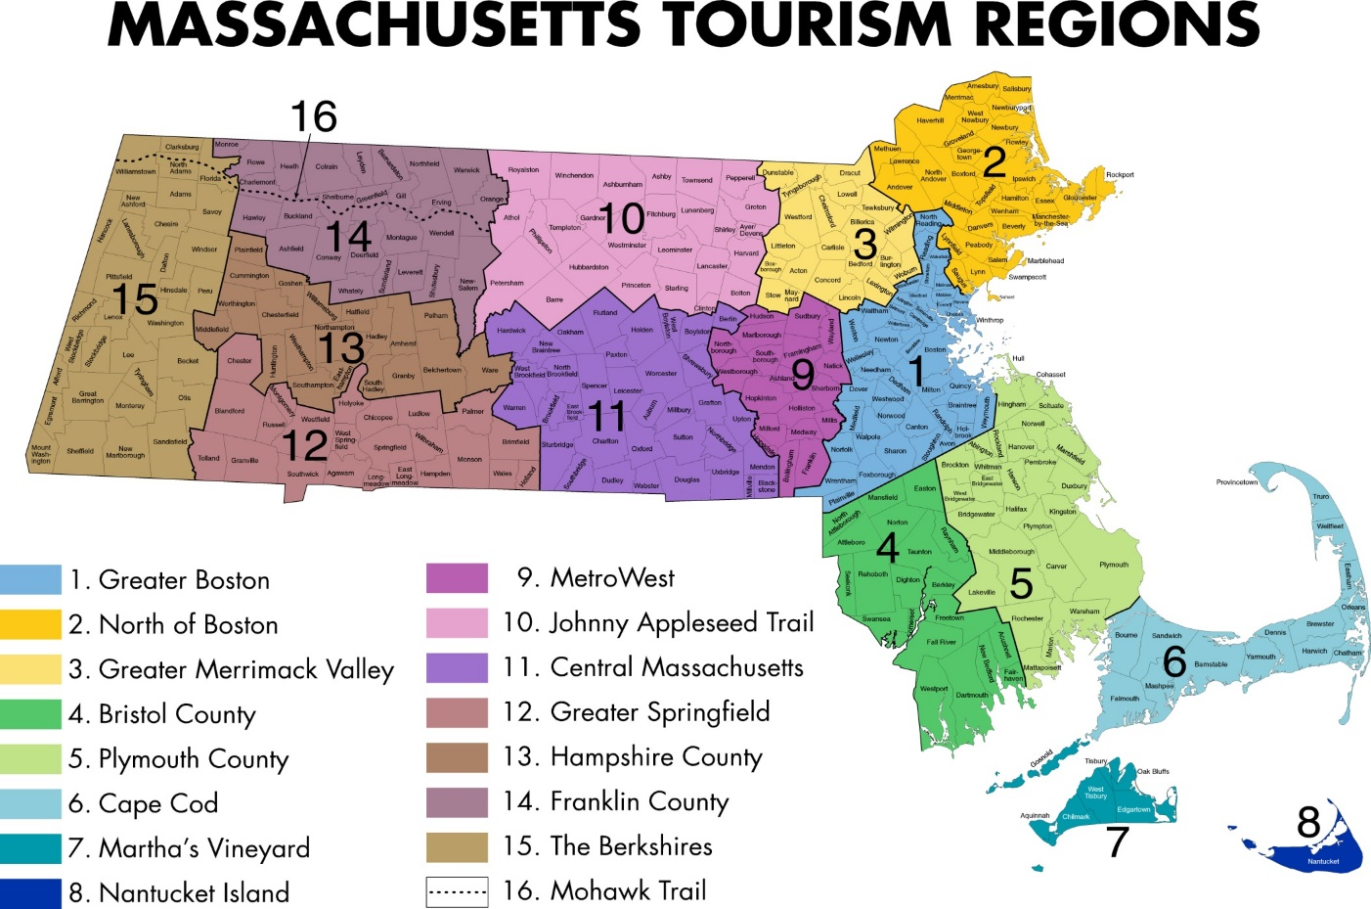

ORGANIZATION NAME:
SUBMISSION DATE:
APPLICATION OVERVIEW
The Massachusetts Office of Travel and Tourism (MOTT) has established a program for financial assistance to public or nonprofit agencies which promote or provide services for tourism, convention, travel, and recreation in the Commonwealth.
Funds shall be used to strengthen efforts of tourism, convention, travel, and recreation agencies to attract and service visitors to the Commonwealth and to better manage and distribute the influx of said visitors. No funds may be used for alcohol, depreciation, contributions, purchase of equipment, or taxes, or for travel, entertainment, meals for either the grantee or their staff.
ELIGIIBILITY REQUIREMENTS
Agencies identified as Regional Tourism Councils, representing the following designated service areas: Greater Boston, North of Boston, Greater Merrimack Valley, Bristol County, Plymouth County, Cape Cod, Martha’s Vineyard, Nantucket Island, MetroWest, Johnny Appleseed Trail, Central Massachusetts, Greater Springfield, Hampshire County, Franklin County, The Berkshires, and Mohawk Trail.
Any other public or nonprofit agency which fulfills the following requirements:
- In operation for two consecutive years prior to applying for this grant
- Spends $15,000 in its fiscal year on tourism or a public or nonprofit agency
- Has a total budget larger than the average of Massachusetts tourist promotion agencies as estimated by the executive director of MOTT and which spends 25% percent of said budget on tourism
MATCHING REQUIREMENTS
The applicant is required to report amount of nongovernmental (i.e. private) funds held by, committed, or subscribed to the applicant for application to the proposals herein described and the amount of the grant for which application is made. The maximum received by the applicant shall be no greater than the amount received from non-governmental sources.

Eligibility Confirmation and/or Application Questions
If you have any questions about your eligibility, application procedures, or the application in general, please contact MOTT directly. All inquiries should be directed to Phyllis M. Cahaly, Director of Specialized Marketing for the Massachusetts Office of Travel & Tourism:
Phone: 617-973-8509 | email phyllis.cahaly@mass.gov

APPLICATION CRITERIA AND REVIEW PROCESS
The amount of funds received by any one agency shall be based on the following weighted criteria (see addendum for further detail):
(1) economic impact of the designated service area of the applicant: 50%
(2) matching funds from nongovernmental sources: 20%
(3) demonstrated marketing effectiveness, integration of promotional plan with other private and public agency plans, assurance that the funded proposal will be in addition to the work currently being done by the agency, and that the agency will maintain a continued effort of the funded program: 30%

The following marketing plan application is for the purpose of demonstrating marketing effectiveness, which accounts for 30% of the applicant’s total score. Upon submission of the application, a committee will review the strength of the applicant in each of the 3 categories above. The applicant may request to present the marketing plan to the committee following its submission. Presentations will take place from July 16 – July 27, 2018. Grant notifications will occur shortly after awards have been approved and will be contingent on confirmation of fund availability from the Commonwealth. MOTT staff will also be available to provide follow-up information and panel comments after the grant notifications have been sent. 2019 grant decisions will be announced in August 2018, contingent upon appropriation.

DEADLINE
Final Application Deadline: 5:00 pm (ET), July 9, 2018

Please submit this signed application by email or digital file transfer to Phyllis M. Cahaly at phyllis.cahaly@mass.gov

Section 1: APPLICANT INFORMATION
- Describe your organization, using templates where provided.
- When submitting the application, please title file names of attachments as follows: OrgName_Section-Part (e.g. MOTT_1-b)

Part 1-a) CONTACT INFORMATION AND REQUIRED SIGNATURES
Organization Name:
Federal Tax ID:
Physical Address (no P.O. boxes):
Email address:
Phone:
Website:

Executive Director/President/CEO

___________________________________________________
Signature Date

__________________________________________________
Print Full Name Title

Official submitting FY19 grant application

___________________________________________________
Signature Date

__________________________________________________
Print Full Name Title

Fiscal Officer

___________________________________________________
Signature Date

__________________________________________________
Print Full Name Title

Chair, Board of Directors

___________________________________________________
Signature Date

__________________________________________________
Print Full Name Title
Part 1-b) REVENUE REPORT
- Provide a report on FY18 revenue and your proposed budget for FY19 using the template provided.
- Title the attachment 1-b.
- Exclude all revenues not related to the development and operation of travel and tourism marketing programs and services.
- Note: the final fiscal year 2018 revenue report is due July 31, 2018.

Part 1-c) STAFF LIST
- Attach a list of personnel including the following details for each staff member.
- Title the attachment 1-c.

Name
Title
Brief Job Description
Email Address
Phone Number
Full time or part time
Salary/Hourly-rate

Part 1-d) BOARD OF DIRECTORS
- Attach a list of the Board of Directors of your organization including the details listed below. Please list executive Board Members first.
- Title the attachment 1-d.

Name
Title
Organization, Title
Business Address
Email Address
Phone Number

End of Section 1

Section 2: MARKETING PLAN
- Describe your FY19 marketing plan using the templates provided. Modify templates as needed, keeping all responses clear and concise.
- Title all attachments as follows: OrgName_Section-Part (e.g. MOTT_2-a)
- This section will be the subject of voluntary in-person marketing plan presentations. Presentations may take place from July 16 – July 27, 2018.
- To schedule a presentation, please email Annie Moloney at annie.moloney@mass.gov

Part 2-a) TARGET MARKETS

- Identify your top 3 - 5 target markets for FY19 using the template provided. Title the attachment 2-a.
- For each target market, provide a description that includes spending habits and other demographic details used to shape marketing decisions. Strong profiles include DMA or region of origin, age range, interests, and familiarity with your region.

Part 2-b) MARKETING STRATEGIES AND BUDGET

- Describe each FY19 marketing strategy and budget using the template provided. Title the attachment 2-b.
- Successful marketing strategies will refer to the target markets identified in the previous section.
- Additional consideration will be given for plans that demonstrate integration of promotions with other private and public agency plans.

Part 2-c) MEDIA FLOW CHART

- Identify your planned media buying schedule. Use the template provided, or submit your own media flow chart. Title the attachment 2-c.
- Note: An updated media flow chart is due once receipt of the actual FY19 allocation is awarded.

Part 2-d) CASE STUDY

- Describe a successful marketing program implemented by your organization in FY18 using the template provided. Title the attachment 2-d.

End of Application

