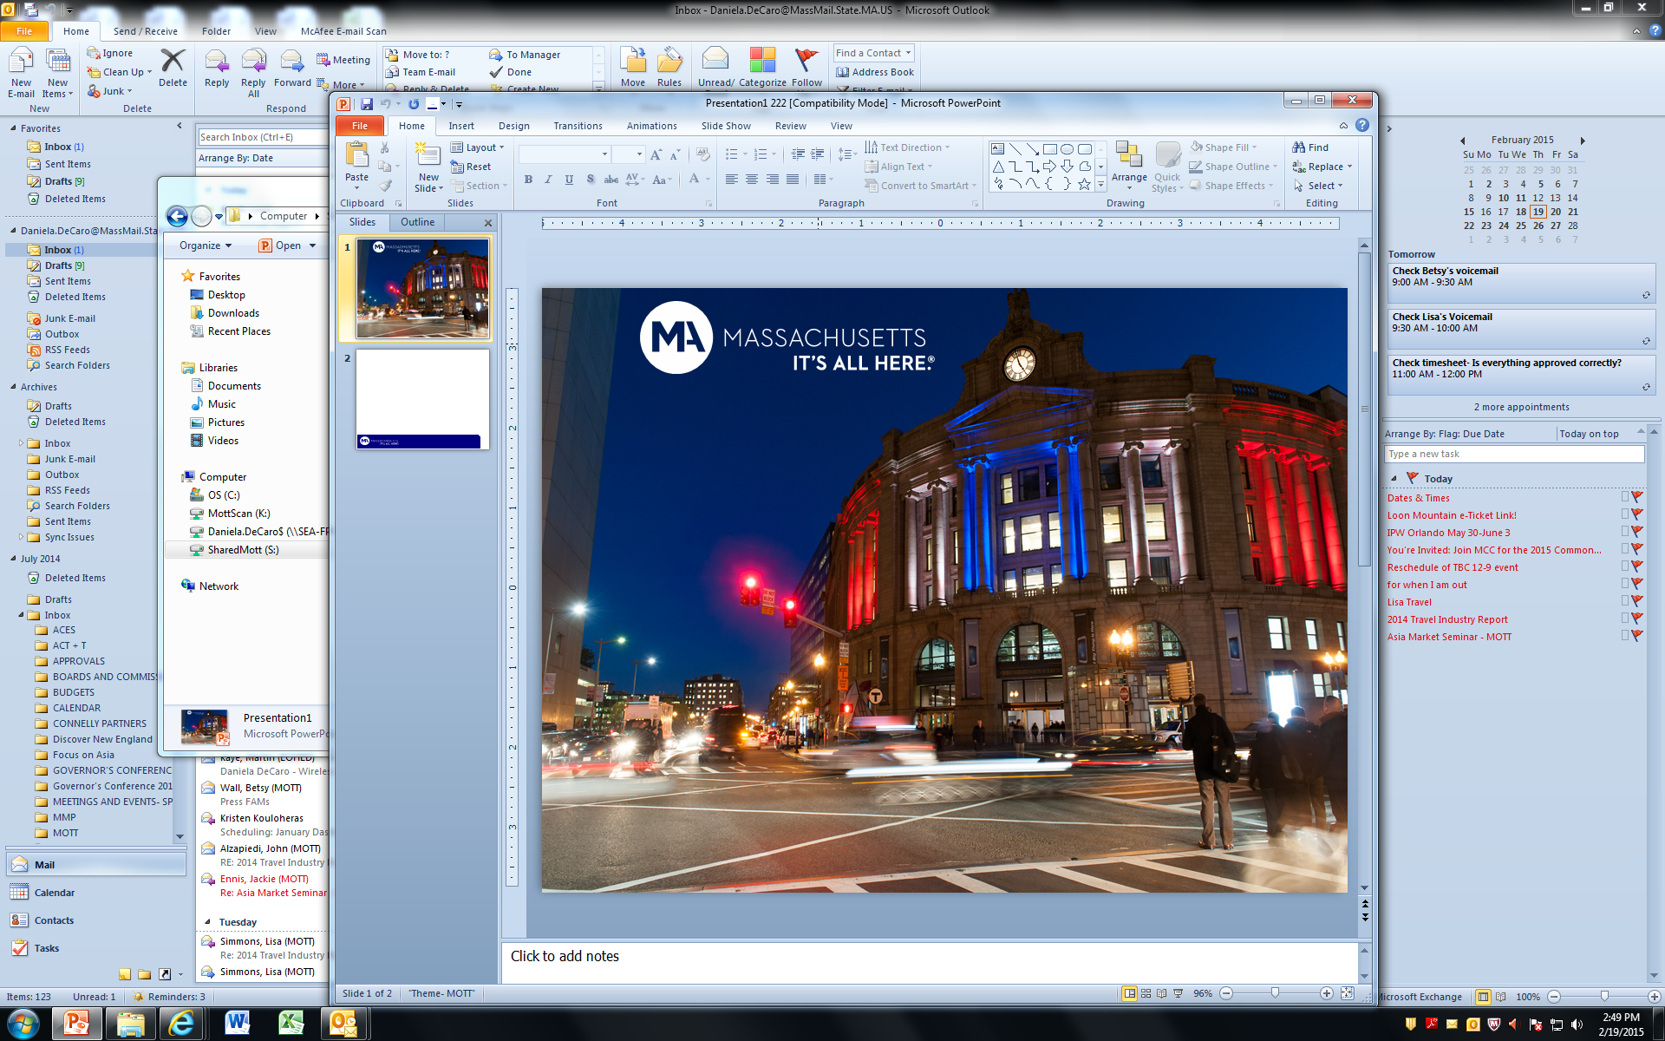

**Massachusetts Office of Travel and Tourism**

**Legislative Report**

**International Tourism Marketing**

**March 1, 2015**

**Economic Development Legislation:**

7008-1015 For the Massachusetts office of travel and tourism; provided, that with a focus on increasing visitation and spending from countries, the office shall expend funds for marketing the commonwealth in international markets to travellers; provided further, that no funds from this item shall supplant the funding appropriated in 7008-0900; provided further, that the office shall submit an annual report not later than March 1 on the effectiveness of the international marketing plan including, but not limited to, the following information: (i) the projects and amounts expended by location; (ii) the plan to expand to emerging international markets by location; (iii) barriers to expanding to emerging international markets by location; (iv) the per cent change in tourism revenue following implementation of the marketing plan; and (v) a cost-benefit analysis of the marketing plan to the clerks of the senate and house of representatives and to the senate and house chairs of the joint committee on tourism, arts and cultural development; and provided further, that all reports shall be made available on the office’s website $5,000,000.

**This report is filed consistent with the legislative language, but please note that the program has been largely defunded by mandated budget cuts:**

* Of the $5 Million that MOTT was allotted for International, $500,000 was cut via 9C in November 2014.
* The remaining balance of $3.5 Million has been targeted by a second round of cuts due to budget considerations.
* MOTT granted Brand USA $1 Million which is described below.
* The remaining balance is $0

**International Marketing Program FY 2015 Objective:**

*To create and implement an international tourism marketing strategy that allocates the provided funds thoughtfully, expertly and as efficiently as possible in growing Massachusetts’ existing core international markets and also developing emerging global markets. We aim for the capable and effective use of funds to generate the maximum return on the dollars invested and at the same time, provide a solid base for the continued global promotion of the Massachusetts brand.*

*Core markets:*

*Canada, France, Germany, Ireland, Japan, UK, Italy*

*Emerging markets:*

*China, India, India, Brazil*

*Recent new nonstop air service to Boston:*

*Beijing, Shanghai, Mumbai, Mexico City, Tel Aviv, Dubai*



**Latest International Tourism Statistics**

**2/13/15**



* **Calendar Year 2014 volume data to U.S. states not available until June, 2015.**
* **Calendar Year 2013 International visitation to MA totaled $2.1 Million and generated $2.5 million in spending.**
* **Visitation to U.S. from MA target markets in 2014 through November up approximately 5%.**

**Route Development Assistance:**

* The following is marketing contracts and specific dollars as relevant to airlines in core markets. In the core markets, all promotional expenditure goes to support overall success of routes in that market.



**Brand USA Communication Plan 2015: Overview**

Brand USA China consumer media plan

